tlook on the web

Open the shared mailbox in a separate browser window
Use this method if you want to view and manage the email rules for the shared mailbox in its own browser window.
- Sign in to your account in Outlook on the web.
- On the Outlook on the web navigation bar, select your name in the upper right corner.
- Choose Open another mailbox
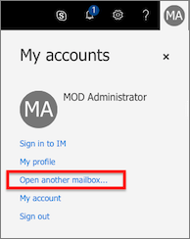
- Enter the email address of the shared mailbox that you want to access and select Open.
Another Outlook on the web session opens in a separate window, allowing access to the shared mailbox.

Set a rule in Outlook on the web for a shared mailbox
- Select the Settings menu icon and choose Mail.
- In the Mail > Automatic processing section choose Inbox and sweep rules.
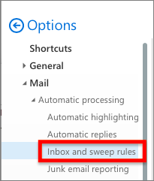
- In the Inbox Rules section choose the + (plus) icon to add a new rule.
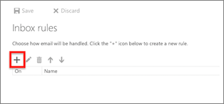
- Give the rule an appropriate name.
- Add conditions, actions, and exceptions accordingly.
- Select OK above the rule wizard to save the rule.

